STP Principles and Configuration



Huawei Technologies Co., Ltd.

|  |
| --- |
| **Copyright © Huawei Technologies Co., Ltd. 2020. All rights reserved.**  No part of this document may be reproduced or transmitted in any form or by any means without prior written consent of Huawei Technologies Co., Ltd.  **Trademarks and Permissions**  HW_POS_RBG_Vertical-150ppi.png and other Huawei trademarks are trademarks of Huawei Technologies Co., Ltd.  All other trademarks and trade names mentioned in this document are the property of their respective holders.  **Notice**  The purchased products, services and features are stipulated by the contract made between Huawei and the customer. All or part of the products, services and features described in this document may not be within the purchase scope or the usage scope. Unless otherwise specified in the contract, all statements, information, and recommendations in this document are provided "AS IS" without warranties, guarantees or representations of any kind, either express or implied.  The information in this document is subject to change without notice. Every effort has been made in the preparation of this document to ensure accuracy of the contents, but all statements, information, and recommendations in this document do not constitute a warranty of any kind, express or implied. |

|  |  |
| --- | --- |
| Huawei Technologies Co., Ltd. | |
| Address: | Huawei Industrial Base  Bantian, Longgang  Shenzhen 518129  People's Republic of China |
| Website: | <https://e.huawei.com/> |

**Huawei Certification System**

Huawei Certification follows the "platform + ecosystem" development strategy, which is a new collaborative architecture of ICT infrastructure based on "Cloud-Pipe-Terminal". Huawei has set up a complete certification system consisting of three categories: ICT infrastructure certification, platform and service certification, and ICT vertical certification. It is the only certification system that covers all ICT technical fields in the industry. Huawei offers three levels of certification: Huawei Certified ICT Associate (HCIA), Huawei Certified ICT Professional (HCIP), and Huawei Certified ICT Expert (HCIE). Huawei Certification covers all ICT fields and adapts to the industry trend of ICT convergence. With its leading talent development system and certification standards, it is committed to fostering new ICT talent in the digital era, and building a sound ICT talent ecosystem.

Huawei Certified ICT Associate-Datacom (HCIA-Datacom) is designed for Huawei's frontline engineers and anyone who want to understand Huawei's datacom products and technologies. The HCIA-Datacom certification covers routing and switching principles, basic WLAN principles, network security basics, network management and O&M basics, SDN and programmability and automation basics.

The Huawei certification system introduces the industry, fosters innovation, and imparts cutting-edge datacom knowledge.

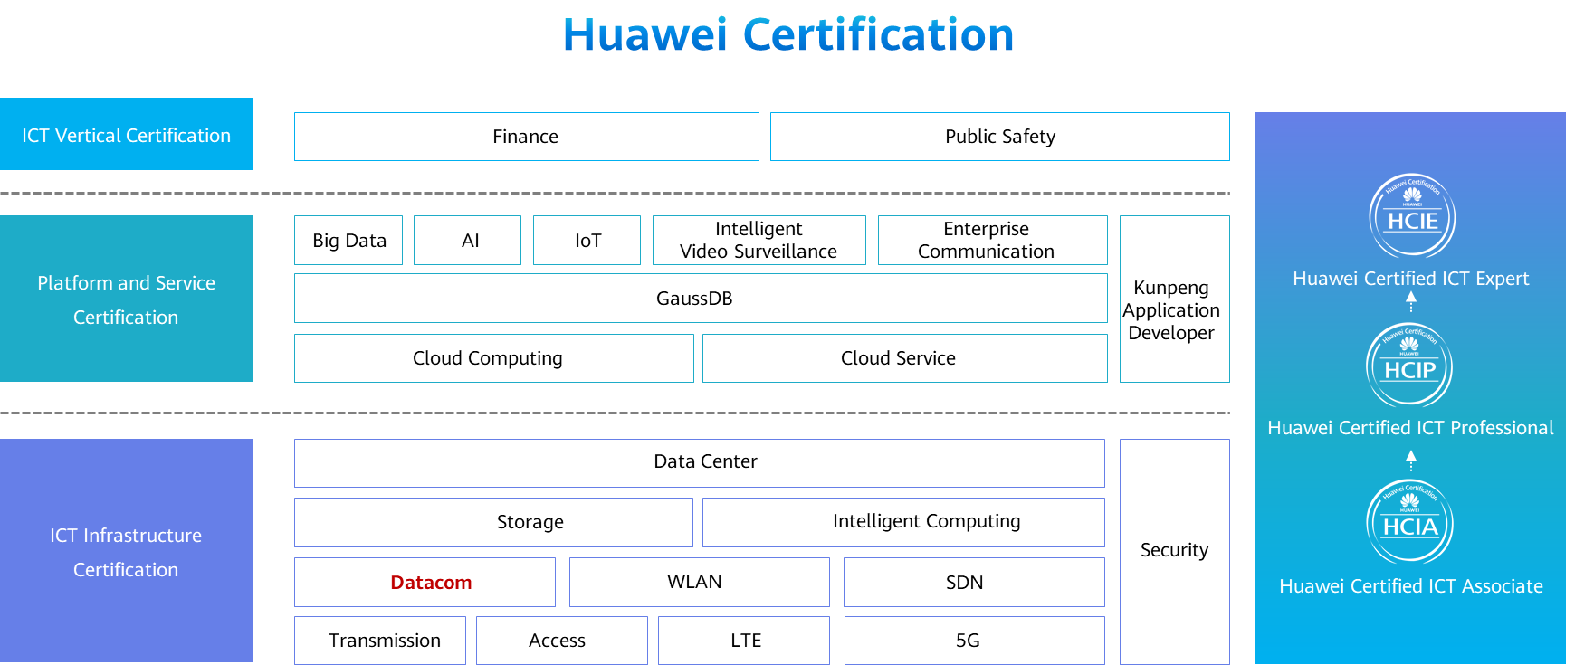

Contents

[1 STP Principles and Configuration 1](#_Toc59716346)

[1.1 Foreword 1](#_Toc59716347)

[1.2 Objectives 1](#_Toc59716348)

[1.3 STP Overview 2](#_Toc59716349)

[1.3.1 Technical Background: Redundancy and Loops on a Layer 2 Switching Network 2](#_Toc59716350)

[1.3.2 Technical Background: Layer 2 Loops Caused by Human Errors 3](#_Toc59716351)

[1.3.3 Issues Caused by Layer 2 Loops 3](#_Toc59716352)

[1.3.4 Introduction to STP 5](#_Toc59716353)

[1.3.5 STP Can Dynamically Respond to Network Topology Changes and Adjust Blocked Ports 5](#_Toc59716354)

[1.3.6 Q&A: Layer 2 and Layer 3 loops 6](#_Toc59716355)

[1.3.7 Application of STP on a Campus Network 7](#_Toc59716356)

[1.3.8 STP Overview 7](#_Toc59716357)

[1.4 Basic Concepts and Working Mechanism of STP 7](#_Toc59716358)

[1.4.1 STP Basic Concepts 7](#_Toc59716359)

[1.4.2 Format of Configuration BPDUs 12](#_Toc59716360)

[1.4.3 BPDU Comparison Rules 13](#_Toc59716361)

[1.4.4 Configuration BPDU Forwarding Process 15](#_Toc59716362)

[1.4.5 STP Calculation 15](#_Toc59716363)

[1.4.6 Quiz 1: Identify the Root Bridge and Port Roles 19](#_Toc59716364)

[1.4.7 Quiz 2: Identify the Root Bridge and Port Roles in the Following Topology 20](#_Toc59716365)

[1.4.8 Quiz 3: Identify the Root Bridge and Port Roles in the Following Topology 20](#_Toc59716366)

[1.4.9 STP Port States 21](#_Toc59716367)

[1.4.10 STP Port State Transition 21](#_Toc59716368)

[1.4.11 Topology Change 22](#_Toc59716369)

[1.4.12 The MAC Address Table Is Incorrect Because the Topology Changes 25](#_Toc59716370)

[1.5 Basic STP Configurations 26](#_Toc59716371)

[1.5.1 Basic STP Configuration Commands 26](#_Toc59716372)

[1.5.2 Case 1: Basic STP Configurations 27](#_Toc59716373)

[1.6 Improvements Made in RSTP 28](#_Toc59716374)

[1.6.1 Disadvantages of STP 28](#_Toc59716375)

[1.6.2 RSTP Overview 29](#_Toc59716376)

[1.6.3 Improvements Made in RSTP 29](#_Toc59716377)

[1.6.4 Port Roles in RSTP 30](#_Toc59716378)

[1.6.5 Edge Port 30](#_Toc59716379)

[1.6.6 Port States in RSTP 31](#_Toc59716380)

[1.7 STP Advancement 31](#_Toc59716381)

[1.7.1 Defects of STP/RSTP: All VLANs Share One Spanning Tree 31](#_Toc59716382)

[1.7.2 VBST 32](#_Toc59716383)

[1.7.3 MSTP 32](#_Toc59716384)

[1.7.4 Stack and Tree Networking of Campus Networks 33](#_Toc59716385)

[1.7.5 Smart Link 34](#_Toc59716386)

[1.8 Quiz 35](#_Toc59716387)

[1.9 Summary 36](#_Toc59716388)

# STP Principles and Configuration

## Foreword

On an Ethernet switching network, redundant links are used to implement link backup and enhance network reliability. However, the use of redundant links may produce loops, leading to broadcast storms and an unstable MAC address table. As a result, communication on the network may deteriorate or even be interrupted. To prevent loops, IEEE introduced the Spanning Tree Protocol (STP).

Devices running STP exchange STP Bridge Protocol Data Units (BPDUs) to discover loops on the network and block appropriate ports. This enables a ring topology to be trimmed into a loop-free tree topology, preventing infinite looping of packets and ensuring packet processing capabilities of devices.

IEEE introduced the Rapid Spanning Tree Protocol (RSTP) to improve the network convergence speed.

## Objectives

On completion of this course, you will be able to:

* Describe the causes and problems of Layer 2 loops on a campus switching network.
* Describe basic concepts and working mechanism of STP.
* Distinguish STP from RSTP and describe the improvement of RSTP on STP.
* Complete basic STP configurations.
* Understand other methods to eliminate Layer 2 loops on the switching network except STP.

## STP Overview

### Technical Background: Redundancy and Loops on a Layer 2 Switching Network

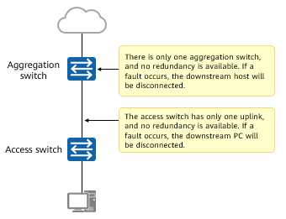

A network without redundancy design

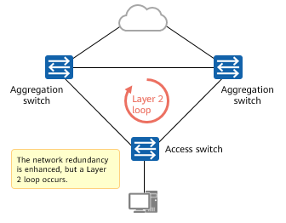

Layer 2 loops introduced along with redundancy

As LANs increase, more and more switches are used to implement interconnection between hosts. As shown in the figure, the access switch is connected to the upstream device through a single link. If the uplink fails, the host connected to the access switch is disconnected from the network. Another problem is the single point of failure (SPOF). That is, if the switch breaks down, the host connected to the access switch is also disconnected.

To solve this problem, switches use redundant links to implement backup. Although redundant links improve network reliability, loops may occur. Loops cause many problems, such as communication quality deterioration and communication service interruption.

### Technical Background: Layer 2 Loops Caused by Human Errors

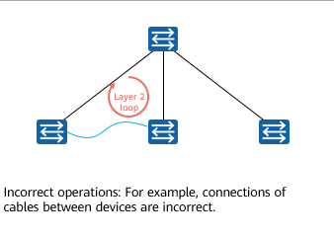

Case 1

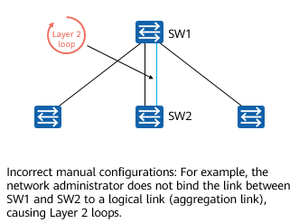

Case 2

In practice, redundant links may cause loops, and some loops may be caused by human errors.

### Issues Caused by Layer 2 Loops

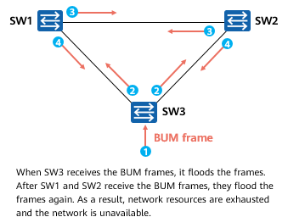

Typical Issue 1: Broadcast Storm

Issue 1: Broadcast storm

* According to the forwarding principle of switches, if a switch receives a broadcast frame or a unicast frame with an unknown destination MAC address from an interface, the switch forwards the frame to all other interfaces except the source interface. If a loop exists on the switching network, the frame is forwarded infinitely. In this case, a broadcast storm occurs and repeated data frames are flooded on the network.
* In this example, SW3 receives a broadcast frame and floods it. SW1 and SW2 also forward the frame to all interfaces except the interface that receives the frame. As a result, the frame is forwarded to SW3 again. This process continues, causing a broadcast storm. The switch performance deteriorates rapidly and services are interrupted.

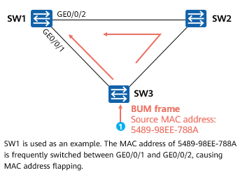

Typical Issue 2: MAC Address Flapping

Issue 2: MAC address flapping

* A switch generates a MAC address table based on source addresses of received data frames and receive interfaces.
* In this example, SW1 learns and floods the broadcast frame after receiving it from GE0/0/1, forming the mapping between the MAC address 5489-98EE-788A and GE0/0/1. SW2 learns and floods the received broadcast frame. SW1 receives the broadcast frame with the source MAC address 5489-98EE-788A from GE0/0/2 and learns the MAC address again. Then, the MAC address 5489-98EE-788A is switched between GE0/0/1 and GE0/0/2 repeatedly, causing MAC address flapping.

### Introduction to STP

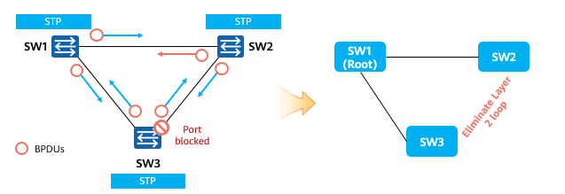

STP

When STP is deployed on a network, switches exchange STP BPDUs and calculate a loop-free topology. Finally, one or more ports on the network are blocked to eliminate loops.

On an Ethernet network, loops on a Layer 2 network may cause broadcast storms, MAC address flapping, and duplicate data frames. STP is used to prevent loops on a switching network.

STP constructs a tree to eliminate loops on the switching network.

The STP algorithm is used to detect loops on the network, block redundant links, and prune the loop network into a loop-free tree network. In this way, proliferation and infinite loops of data frames are avoided on the loop network.

### STP Can Dynamically Respond to Network Topology Changes and Adjust Blocked Ports

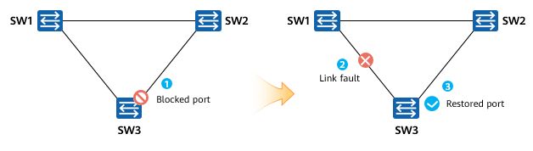

STP

STP running on a switch continuously monitors the network topology. When the network topology changes, STP can detect the changes and automatically adjust the network topology.

Therefore, STP can solve the Layer 2 loop problem and provide a solution for network redundancy.

As shown in the preceding figure, switches run STP and exchange STP BPDUs to monitor the network topology. Normally, a port on SW3 is blocked to prevent the loop. When the link between SW1 and SW3 is faulty, the blocked port is unblocked and enters the forwarding state.

### Q&A: Layer 2 and Layer 3 loops

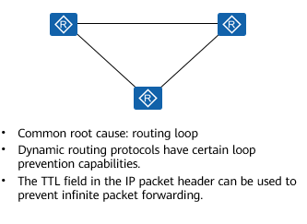

Layer 3 loop

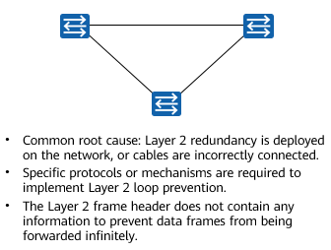

Layer 2 loop

Common loops are classified into Layer 2 and Layer 3 loops.

Layer 2 loops are caused by Layer 2 redundancy or incorrect cable connections. You can use a specific protocol or mechanism to prevent Layer 2 loops.

Layer 3 loops are mainly caused by routing loops. Dynamic routing protocols can be used to prevent loops and the TTL field in the IP packet header can be used to prevent packets from being forwarded infinitely.

### Application of STP on a Campus Network

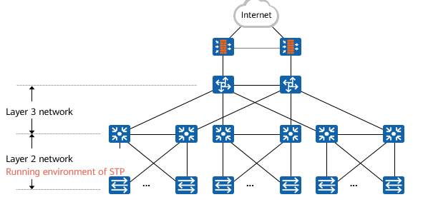

Application of STP on a campus network

STP is used on Layer 2 networks of campus networks to implement link backup and eliminate loops.

### STP Overview

STP is used on a LAN to prevent loops.

Devices running STP exchange information with one another to discover loops on the network, and block certain ports to eliminate loops.

After running on a network, STP continuously monitors the network status. When the network topology changes, STP can detect the change and automatically respond to the change. In this way, the network status can adapt to the new topology, ensuring network reliability.

With the growth in scale of LANs, STP has become an important protocol for a LAN.

## Basic Concepts and Working Mechanism of STP

### STP Basic Concepts

1、BID

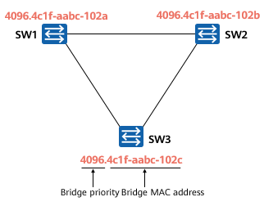

BID

Bridge ID (BID)

* As defined in IEEE 802.1D, a BID consists of a 16-bit bridge priority and a bridge MAC address.
* Each switch running STP has a unique BID.
* The bridge priority occupies the leftmost 16 bits and the MAC address occupies the rightmost 48 bits.
* On an STP network, the device with the smallest BID acts as the root bridge.

In STP, each switch has a bridge ID (BID), which consists of a 16-bit bridge priority and a 48-bit MAC address. On an STP network, the bridge priority is configurable and ranges from 0 to 65535. The default bridge priority is 32768. The bridge priority can be changed but must be a multiple of 4096. The device with the highest priority (a smaller value indicates a higher priority) is selected as the root bridge. If the priorities are the same, devices compare MAC addresses. A smaller MAC address indicates a higher priority.

As shown in the figure, the root bridge needs to be selected on the network. The three switches first compare bridge priorities. The bridge priorities of the three switches are 4096. Then the three switches compare MAC addresses. The switch with the smallest MAC address is selected as the root bridge.

2、Root Bridge

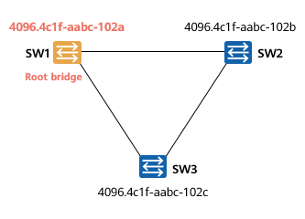

Root Bridge

Root Bridge

* One of the main functions of STP is to calculate a loop-free STP tree on the entire switching network.
* The root bridge is the root of an STP network.
* After STP starts to work, it elects a root bridge on the switching network. The root bridge is the key for topology calculation of the spanning tree and is the root of the loop-free topology calculated by STP.
* On an STP network, the device with the smallest BID acts as the root bridge.
* During BID comparison, devices first compare bridge priorities. A smaller priority value indicates a higher priority of a device. The switch with the smallest priority value becomes the root bridge. If priority values are the same, the switch with the smallest MAC address becomes the root bridge.

The root bridge functions as the root of a tree network.

It is the logical center, but not necessarily the physical center, of the network. The root bridge changes dynamically with the network topology.

After network convergence is completed, the root bridge generates and sends configuration BPDUs to other devices at specific intervals. Other devices process and forward the configuration BPDUs to notify downstream devices of topology changes, ensuring that the network topology is stable.

3、Cost

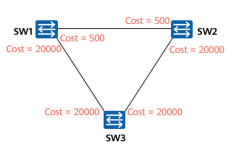

Cost

Cost

* Each STP-enabled port maintains a cost. The cost of a port is used to calculate the root path cost (RPC), that is, the cost of the path to the root.
* The default cost of a port is related to the rate, working mode, and STP cost calculation method used by a switch.
* A higher port bandwidth indicates a smaller cost.
* You can also run commands to adjust the cost of a port as required.

Each port on a switch has a cost in STP. By default, a higher port bandwidth indicates a smaller port cost.

Huawei switches support multiple STP path cost calculation standards to provide better compatibility in scenarios where devices from multiple vendors are deployed. By default, Huawei switches use IEEE 802.1t to calculate the path cost.

4、Cost Calculation Methods

Cost Calculation Methods

|  |  |  |  |  |
| --- | --- | --- | --- | --- |
| Port Rate | Port Mode | Recommended STP Cost | | |
| **IEEE 802.1d-1998** | **IEEE 802.1t** | **Huawei Legacy Standard** |
| 100 Mbit/s | Half-duplex | 19 | 200,000 | 200 |
| Full-duplex | 18 | 199,999 | 199 |
| Aggregated link: two ports | 15 | 100,000 | 180 |
| 1000 Mbit/s | Full-duplex | 4 | 20,000 | 20 |
| Aggregated link: two ports | 3 | 10,000 | 18 |
| 10 Gbit/s | Full-duplex | 2 | 2000 | 2 |
| Aggregated link: two ports | 1 | 1000 | 1 |
| 40 Gbit/s | Full-duplex | 1 | 500 | 1 |
| Aggregated link: two ports | 1 | 250 | 1 |
| 100 Gbit/s | Full-duplex | 1 | 200 | 1 |
| Aggregated link: two ports | 1 | 100 | 1 |

The cost has a default value and is associated with the port rate. When the device uses different algorithms, the same port rate corresponds to different cost values.

5、RPC

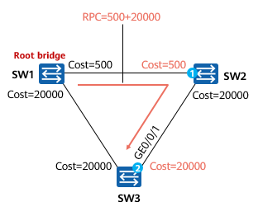

RPC

RPC

* The cost from a switch port to the root bridge, that is, RPC, is important during STP topology calculation.
* The RPC from a port to the root bridge is the sum of costs of all inbound ports along the path from the root bridge to the device.
* In this example, the RPC for SW3 to reach the root bridge through GE0/0/1 is equal to the cost of port 1 plus the cost of port 2.

There may be multiple paths from a non-root bridge to the root bridge. Each path has a total cost, which is the sum of all port costs on this path. A non-root bridge compares the costs of multiple paths to select the shortest path to the root bridge. The path cost of the shortest path is called the root path cost (RPC), and a loop-free tree network is generated. The RPC of the root bridge is 0.

6、PID

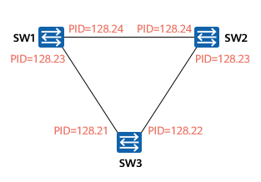

PID

Port ID (PID)

* An STP-enabled switch uses PIDs to identify ports. A PID is used to elect a designated port in a specific scenario.
* A PID consists of the leftmost four bits (port priority) and the rightmost 12 bits (port number).
* An STP-enabled port maintains a default port priority, which is 128 on Huawei switches. You can run a command to change the priority as required.

Each port on an STP-enabled switch has a port ID, which consists of the port priority and port number. The value of the port priority ranges from 0 to 240, with an increment of 16. That is, the value must be an integer multiple of 16. By default, the port priority is 128. The PID is used to determine the port role.

7、BPDU

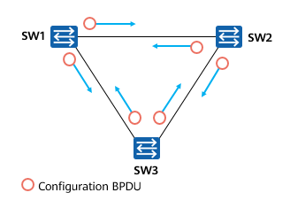

BPDU

Bridge Protocol Data Unit (BPDU)

* BPDU is the basis for STP to work normally.
* STP-enabled switches exchange BPDUs that carry important information.
* There are two types of BPDUs:
  + Configuration BPDU
  + Topology Change Notification (TCN) BPDU
* Configuration BPDUs are the key to STP topology calculation. TCN BPDUs are triggered only when the network topology changes.

Switches exchange BPDUs where information and parameters are encapsulated to calculate spanning trees.

BPDUs are classified into configuration BPDUs and TCN BPDUs.

A configuration BPDU contains parameters such as the BID, path cost, and PID. STP selects the root bridge by transmitting configuration BPDUs between switches and determines the role and status of each switch port. Each bridge proactively sends configuration BPDUs during initialization. After the network topology becomes stable, only the root bridge proactively sends configuration BPDUs. Other bridges send configuration BPDUs only after receiving configuration BPDUs from upstream devices.

A TCN BPDU is sent by a downstream switch to an upstream switch when the downstream switch detects a topology change.

### Format of Configuration BPDUs



BPDU

BPDU

|  |  |  |
| --- | --- | --- |
| Byte | Field | Description |
| 2 | PID | For STP, the value of this field is always 0. |
| 1 | PVI | For STP, the value of this field is always 0. |
| 1 | BPDU Type | Type of BPDUs. The value 0x00 indicates a configuration BPDU and the value 0x80 indicates a TCN BPDU. |
| 1 | Flags | STP uses only the leftmost two bits and the rightmost two bits: Topology Change Acknowledgment (TCA) and Topology Change (TC). |
| 8 | Root D | BID of the root bridge. |
| 4 | RPC | STP cost of the path from the current port to the root bridge. |
| 8 | Bridge ID | BID of the sender. |
| 2 | Port ID | ID of the port that sends this BPDU, which consists of the port priority and port number. |
| 2 | Message Age | Number of seconds after a BPDU is sent from the root bridge. The value increases by 1 each time the BPDU passes through a network bridge. It refers to the number of hops to the root bridge. |
| 2 | Max Age | If the bridge does not receive any BPDU for a period of time and the lifetime of the network bridge reaches the maximum, the network bridge considers that the link connected to the port is faulty.  The default value is 20s. |
| 2 | Hello Time | Interval at which the root bridge sends configuration BPDUs. The default value is 2s. |
| 2 | Forward Delay | Time that is spent in Listening or Learning state. The default value is 15s. |

### BPDU Comparison Rules

Field

|  |
| --- |
| Field |
| Protocol Identifier |
| Protocol Version Identifier |
| BPDU Type |
| Flags |
| Root Identifier |
| Root Path Cost |
| Bridge Identifier |
| Port Identifier |
| Message Age |
| Max Age |
| Hello Time |
| Forward Delay |

The core of STP is to calculate a loop-free topology on a switching network. During topology calculation, the comparison of configuration BPDUs is important. The Root Identifier, Root Path Cost, Bridge Identifier, and Port Identifier fields are the main fields of a configuration BPDU. STP-enabled switches compare the four fields.

STP selects the optimal configuration BPDU in the following sequence:

* Smallest BID of the root bridge
* Smallest RPC
* Smallest BID of the network bridge
* Smallest PID

Among the four rules (each rule corresponds to a field in a configuration BPDU), the first rule is used to elect the root bridge on the network, and the following rules are used to elect the root port and designated port.

* STP operations:
* Selects a root bridge.
* Each non-root switch elects a root port.
* Select a designated port for each network segment.

Blocks non-root and non-designated ports.

STP defines three port roles: designated port, root port, and alternate port.

A designated port is used by a switch to forward configuration BPDUs to the connected network segment. Each network segment has only one designated port. In most cases, each port of the root bridge is a designated port.

The root port is the port on the non-root bridge that has the optimal path to the root bridge. A switch running STP can have only one root port, but the root bridge does not have any root port.

If a port is neither a designated port nor a root port, the port is an alternate port. The alternate port is blocked.

### Configuration BPDU Forwarding Process

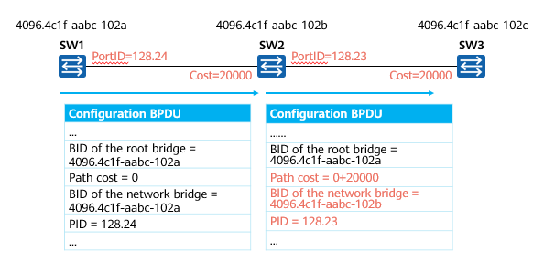

Configuration BPDU Forwarding Process

When a switch starts, it considers itself as the root bridge and sends configuration BPDUs to each other for STP calculation.

### STP Calculation

1、Select a Root Bridge on the Switching Network

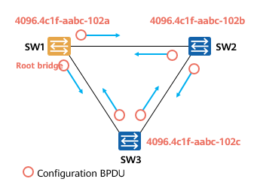

Select a Root Bridge on the Switching Network

Select a Root Bridge on the Switching Network

* After STP starts to work on a switching network, each switch sends configuration BPDUs to the network. The configuration BPDU contains the BID of a switch.
* The switch with the smallest bridge ID becomes the root bridge.
* Only one root bridge exists on a contiguous STP switching network.
* The role of the root bridge can be preempted.
* To ensure the stability of the switching network, you are advised to plan the STP network in advance and set the bridge priority of the switch that is planned as the root bridge to the minimum value 0.

What is a root bridge?

* The root bridge is the root node of an STP tree.
* To generate an STP tree, first determine a root bridge.
* It is the logical center, but not necessarily the physical center, of the network.
* When the network topology changes, the root bridge may also change. (The role of the root bridge can be preempted.)

Election process:

* When an STP-enabled switch is started, it considers itself as the root bridge and declares itself as the root bridge in the BPDUs sent to other switches. In this case, the BID in the BPDU is the BID of each device.
* When a switch receives a BPDU from another device on the network, it compares the BID in the BPDU with its own BID.
* Switches exchange BPDUs continuously and compare BIDs. The switch with the smallest BID is selected as the root bridge, and other switches are non-root bridges.
* As shown in the figure, the priorities of SW1, SW2, and SW3 are compared first. If the priorities of SW1, SW2, and SW3 are the same, MAC addresses are compared. The BID of SW1 is the smallest, so SW1 is the root bridge, and SW2 and SW3 are non-root bridges.

Note:

The role of the root bridge can be preempted. When a switch with a smaller BID joins the network, the network performs STP calculation again to select a new root bridge.

2、Select a Root Port on Each Non-root Bridge

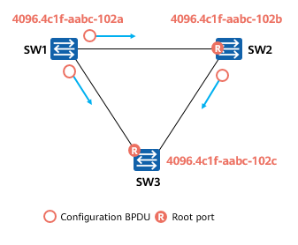

Select a Root Port on Each Non-root Bridge

Select a Root Port on Each Non-root Bridge

* Each non-root bridge selects a root port from its ports.
* A non-root bridge has only one root port.
* When a non-root-bridge switch has multiple ports connected to the network, the root port receives the optimal configuration BPDU.
* The root port is located on each non-root bridge and has the shortest distance away from the root bridge.

What is a root port?

* A non-root bridge may have multiple ports connected to a network. To ensure that a working path from a non-root bridge to a root bridge is optimal and unique, the root port needs to be determined among ports of the non-root bridge. The root port is used for packet exchange between the non-root bridge and the root bridge.
* After the root bridge is elected, the root bridge still continuously sends BPDUs, and the non-root bridge continuously receives BPDUs from the root bridge. Therefore, the root port closest to the root bridge is selected on all non-root bridges. After network convergence, the root port continuously receives BPDUs from the root bridge.
* That is, the root port ensures the unique and optimal working path between the non-root bridge and the root bridge.

Note: A non-root bridge can have only one root port.

Election process:

* A switch has multiple ports connected to a network. Each port receives a BPDU carrying main fields such as RootID, RPC, BID, and PID. The ports compare these fields.
* First, RPCs are compared.STP uses the RPC as an important basis to determine the root port. A smaller RPC indicates a higher priority of selecting the root port. Therefore, the switch selects the port with the smallest RPC as the root port.
* When the RPCs are the same, BIDs in the BPDUs received by ports of a switch are compared. A smaller BID indicates a higher priority of electing the root port, so the switch selects the port with the smallest BID as the root port.
* When the BIDs are the same, PIDs in the BPDUs received by ports of a switch are compared. A smaller PID indicates a higher priority of electing the root port, so the switch selects the port with the smallest PID as the root port.
* When the PIDs are the same, PIDs of ports on the local switch are compared. A smaller PID indicates a higher priority of electing the root port, so the switch selects the port with the smallest PID as the root port.

3、A designated port is elected on each link.

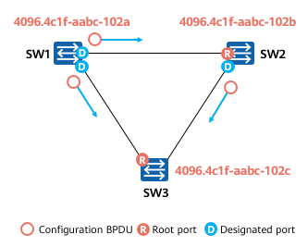

A designated port is elected on each link

A designated port is elected on each link.

* After the root port is elected, the non-root bridge uses the optimal BPDU received on the port to calculate the configuration BPDU and compares the calculated configuration BPDU with the configuration BPDUs received by all ports except the root port.
  + If the former is better, the port is a designated port.
  + If the latter is better, the port is not a designated port.
* In most cases, all ports on the root bridge are designated ports.

What is a designated port?

* The working path between each link and the root bridge must be unique and optimal. When a link has two or more paths to the root bridge (the link is connected to different switches, or the link is connected to different ports of a switch), the switch (may be more than one) connected to the link must determine a unique designated port.
* Therefore, a designated port is selected for each link to send BPDUs along the link.

Note: Generally, the root bridge has only designated ports.

Election process:

* The designated port is also determined by comparing RPCs. The port with the smallest RPC is selected as the designated port. If the RPCs are the same, the BID and PID are compared.
* First, RPCs are compared.A smaller value indicates a higher priority of electing the designated port, so the switch selects the port with the smallest RPC as the designated port.
* If the RPCs are the same, BIDs of switches at both ends of the link are compared. A smaller BID indicates a higher priority of electing the designated port, so the switch selects the port with the smallest BID as the designated port.
* If the BIDs are the same, PIDs of switches at both ends of the link are compared. A smaller PID indicates a higher priority of electing the designated port, so the switch selects the port with the smallest PID as the designated port.

4、Block Non-designated Port

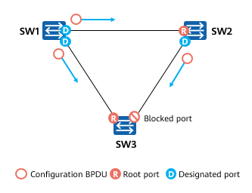

Block Non-designated Port

Block Non-designated Port

* On a switch, a port that is neither a root port nor a designated port is called a non-designated port.
* The last step of STP operations is to block the non-designated port on the network. After this step is complete, the Layer 2 loop on the network is eliminated.

What is a non-designated port (alternate port)?

* After the root port and designated port are determined, all the remaining non-root ports and non-designated ports on the switch are called alternate ports.

Blocking alternate ports

* STP logically blocks the alternate ports. That is, the ports cannot forward the frames (user data frames) generated and sent by terminal computers.
* Once the alternate port is logically blocked, the STP tree (loop-free topology) is generated.

Note:

* The blocked port can receive and process BPDUs.
* The root port and designated port can receive and send BPDUs and forward user data frames.

### Quiz 1: Identify the Root Bridge and Port Roles

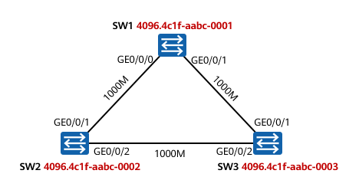

Quiz 1

As shown in the figure, the root bridge is selected first. If the three switches have the same bridge priority, the switch with the smallest MAC address is selected as the root bridge.

GE0/0/1 on SW2 is closest to the root bridge and has the smallest RPC, so GE0/0/1 on SW2 is the root port. Similarly, GE0/0/1 on SW3 is also the root port.

Then designated ports are selected. SW1 is elected as the root bridge, so GE0/0/0 and GE0/0/1 on SW1 are designated ports. GE0/0/2 on SW2 receives configuration BPDUs from SW3 and compares the BIDs of SW2 and SW3. SW2 has a higher BID than SW3, so GE0/0/2 on SW2 is the designated port.

GE0/0/2 on SW3 is the alternate port.

### Quiz 2: Identify the Root Bridge and Port Roles in the Following Topology

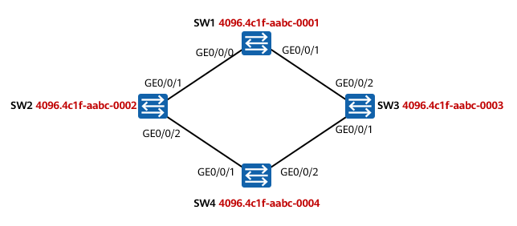

Quiz 2

As shown in the figure, the root bridge is selected first. If the four switches have the same bridge priority, the switch with the smallest MAC address is selected as the root bridge.

GE0/0/1 on SW2 is closest to the root bridge and has the smallest RPC. Therefore, GE0/0/1 on SW2 is the root port. Similarly, GE0/0/2 on SW3 is the root port. The two ports on SW4 have the same RPC. The BID of SW2 connected to GE0/0/1 on SW4 and the BID of SW3 connected to GE0/0/2 on SW4 are compared. The smaller the BID, the higher the priority. Given this, GE0/0/1 on SW4 is selected as the root port.

Then designated ports are selected. SW1 is elected as the root bridge, so GE0/0/0 and GE0/0/1 on SW1 are designated ports. GE0/0/2 on SW2 receives configuration BPDUs from SW4 and compares the RPCs of SW2 and SW4. SW2 has a smaller RPC than SW4, so GE0/0/2 on SW2 is the designated port, and GE0/0/1 on SW3 is the designated port.

GE0/0/2 on SW4 is the alternate port.

### Quiz 3: Identify the Root Bridge and Port Roles in the Following Topology

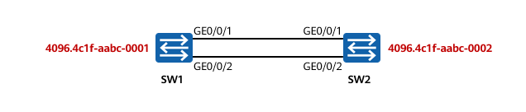

Quiz 3

As shown in the figure, the root bridge is selected first. If the two switches have the same bridge priority, the switch with a smaller MAC address is selected as the root bridge. SW1 is selected as the root bridge.

Then the root port is selected. The two ports on SW2 have the same RPC and BID. The PIDs of the two ports are compared. The PID of G0/0/1 on SW2 is 128.1, and the PID of G0/0/2 on SW2 is 128.2. The smaller the PID, the higher the priority. Therefore, G0/0/1 of SW2 is the root port.

SW1 is the root bridge, so GE0/0/1 and GE0/0/2 on SW1 are designated ports.

GE0/0/2 on SW2 is the alternate port.

### STP Port States

STP Port States

|  |  |
| --- | --- |
| Port State | Description |
| Disabled | The port cannot send or receive BPDUs or service data frames. That is, the port is Down. |
| Blocking | The port is blocked by STP. A blocked port cannot send BPDUs but listens to BPDUs. In addition, the blocked port cannot send or receive service data frames or learn MAC addresses. |
| Listening | STP considers the port in Listening state as the root port or designated port, but the port is still in the STP calculation process. In this case, the port can send and receive BPDUs but cannot send or receive service data frames or learn MAC addresses. |
| Learning | A port in Learning state listens to service data frames but cannot forward them. After receiving service data frames, the port learns MAC addresses. |
| Forwarding | A port in Forwarding state can send and receive service data frames and process BPDUs. Only the root port or designated port can enter the Forwarding state. |

### STP Port State Transition

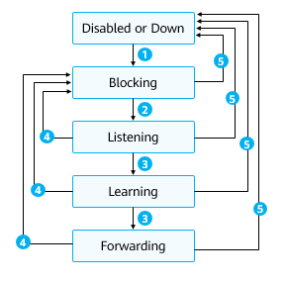

STP Port State Transition

1. When a port is initialized or activated, it automatically enters the blocking state.
2. The port is elected as the root port or designated port and automatically enters the Listening state.
3. The Forward Delay timer expires and the port is still the root port or designated port.
4. The port is no longer the root port or designated port.
5. The port is disabled or the link fails.

The figure shows the STP port state transition. The STP-enabled device has the following five port states:

Forwarding: A port can forward user traffic and BPDUs. Only the root port or designated port can enter the Forwarding state.

Learning: When a port is in Learning state, a device creates MAC address entries based on user traffic received on the port but does not forward user traffic through the port. The Learning state is added to prevent temporary loops.

Listening: A port in Listening state can forward BPDUs, but cannot forward user traffic.

Blocking: A port in Blocking state can only receive and process BPDUs, but cannot forward BPDUs or user traffic. The alternate port is in Blocking state.

Disabled: A port in Disabled state does not forward BPDUs or user traffic.

### Topology Change

1、Root Bridge Fault

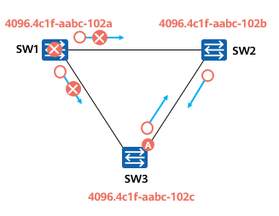

Root Bridge Fault Rectification Process

1. SW1 (root bridge) is faulty and stops sending BPDUs.
2. SW2 waits for the Max Age timer (20s) to expire. In this case, the record about the received BPDUs becomes invalid, and SW2 cannot receive new BPDUs from the root bridge. SW2 learns that the upstream device is faulty.
3. Non-root bridges send configuration BPDUs to each other to elect a new root bridge.
4. After re-election, port A of SW3 transitions to the Forwarding state after two intervals of the Forward Delay timer (the default interval is 15s).

* A non-root bridge starts root bridge re-election after BPDUs age.
* Due to the root bridge failure, it takes about 50s to recover from a root bridge failure.

Root bridge fault:

* On a stable STP network, a non-root bridge periodically receives BPDUs from the root bridge.
* If the root bridge fails, the downstream switch stops sending BPDUs. As a result, the downstream switch cannot receive BPDUs from the root bridge.
* If the downstream switch does not receive BPDUs, the Max Age timer (the default value is 20s) expires. As a result, the record about the received BPDUs becomes invalid. In this case, the non-root bridges send configuration BPDUs to each other to elect a new root bridge.

Port state:

* The alternate port of SW3 enters the Listening state from the Blocking state after 20s and then enters the Learning state. Finally, the port enters the Forwarding state to forward user traffic.

Convergence time:

* It takes about 50s to recover from a root bridge failure, which is equal to the value of the Max Age timer plus twice the value of the Forward Delay timer.

2、Direct Link Fault

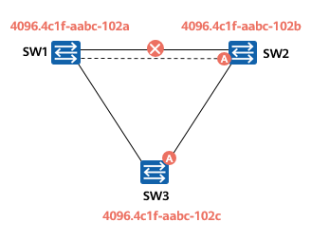

Direct Link Fault Rectification Process

* On a stable network, when SW2 detects that the link of the root port is faulty, the alternate port of SW2 enters the Forwarding state after twice the value of the Forward Delay timer (the default value is 15s).
  + After SW2 detects a fault on the direct link, it switches the alternate port to the root port.
  + If a direct link fails, the alternate port restores to the Forwarding state after 30s.

Direct link fault:

* When two switches are connected through two links, one is the active link and the other is the standby link.
* When the network is stable, SW2 detects that the link of the root port is faulty, and the alternate port enters the Forwarding state.

Port state:

* The alternate port transitions from the Blocking state to the Listening, Learning, Forwarding states in sequence.

Convergence speed:

* If a direct link fails, the alternate port restores to the Forwarding state after 30s.

3、Indirect Link Fault

* When the indirect link fails, the alternate port on SW3 restores to the Forwarding state. It takes about 50s to recover from an indirect link failure.

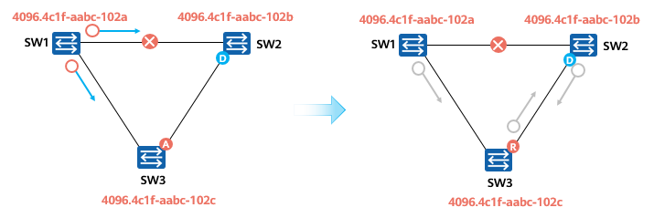

Indirect Link Fault

Indirect link fault:

* On a stable STP network, a non-root bridge periodically receives BPDUs from the root bridge.
* If the link between SW1 and SW2 is faulty (not a physical fault), SW2 cannot receive BPDUs from SW1. The Max Age timer (the default value is 20s) expires. As a result, the record about the received BPDUs becomes invalid.
* In this case, the non-root bridge SW2 considers that the root bridge fails and considers itself as the root bridge. Then SW2 sends its own configuration BPDU to SW3 to notify SW3 that it is the new root bridge.
* During this period, the alternate port of SW3 does not receive any BPDU that contains the root bridge ID. After the Max Age timer expires, the port enters the Listening state and starts to forward the BPDU that contains the root bridge ID from the upstream device to SW2.
* After the Max Age timer expires, SW2 and SW3 receive BPDUs from each other almost at the same time and perform STP recalculation. SW2 finds that the BPDU sent by SW3 is superior, so it does not declare itself as the root bridge and re-determines the port role.

Port state:

* The alternate port of SW3 enters the Listening state from the Blocking state after 20s and then enters the Learning state. Finally, the port enters the Forwarding state to forward user traffic.

Convergence time:

* It takes about 50s to recover from an indirect link failure, which is equal to the value of the Max Age timer plus twice the value of the Forward Delay timer.

### The MAC Address Table Is Incorrect Because the Topology Changes

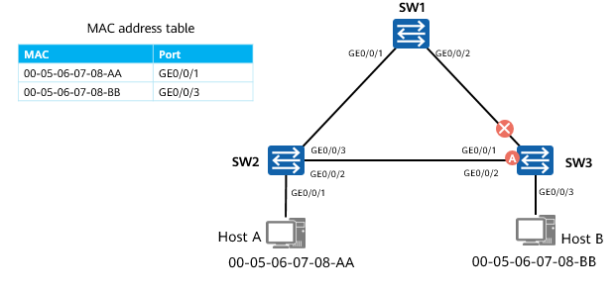

Case 1

As shown in the figure, the root port of SW3 is faulty, causing the spanning tree topology to re-converge. After the spanning tree topology re-converges, Host B cannot receive frames sent by Host A. This is because switches forward data frames based on the MAC address table. By default, the aging time of MAC address entries is 300s. How is forwarding restored rapidly?

On a switching network, a switch forwards data frames based on the MAC address table. By default, the aging time of MAC address entries is 300 seconds. If the spanning tree topology changes, the forwarding path of the switch also changes. In this case, the entries that are not aged in a timely manner in the MAC address table may cause data forwarding errors. Therefore, the switch needs to update the MAC address entries in a timely manner after the topology changes.

In this example, the MAC address entry on SW2 defines that packets can reach Host A through GE0/0/1 and reach Host B through GE0/0/3. The root port of SW3 is faulty, causing the spanning tree topology to re-converge. After the spanning tree topology re-converges, Host B cannot receive frames sent by Host A. This is because the aging time of MAC address entries is 300s. After a frame sent from Host A to Host B reaches SW2, SW2 forwards the frame through GE0/0/3.

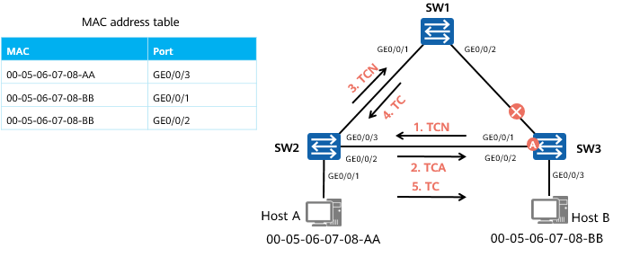

Case 2

* TCN BPDUs are generated when the network topology changes.
* Packet format: protocol identifier, version number, and type
* Topology change: The TCA and TC bits in the Flags field of configuration BPDUs are used.

When the network topology changes, the root bridge sends TCN BPDUs to notify other devices of the topology change. The root bridge generates TCs to instruct other switches to age existing MAC address entries.

The process of topology change and MAC address entry update is as follows:

1. After SW3 detects the network topology change, it continuously sends TCN BPDUs to SW2.
2. After SW2 receives the TCN BPDUs from SW3, it sets the TCA bit in the Flags field of the BPDUs to 1 and sends the BPDUs to SW3, instructing SW3 to stop sending TCN BPDUs.
3. SW2 forwards the TCN BPDUs to the root bridge.
4. SW1 sets the TC bit in the Flags field of the configuration BPDU to 1 and sends the configuration BPDU to instruct the downstream device to change the aging time of MAC address entries from 300s to the value of the Forward Delay timer (15s by default).
5. The incorrect MAC address entries on SW2 are automatically deleted after 15s at most. Then, SW2 starts to learn MAC address entries again and forwards packets based on the learned MAC address entries.

## Basic STP Configurations

### Basic STP Configuration Commands

Configure a working mode.

[Huawei] **stp mode** { **stp** | **rstp** | **mstp** }

The switch supports three working modes: STP, RSTP, and Multiple Spanning Tree Protocol (MSTP). By default, a switch works in MSTP mode. On a ring network running only STP, the working mode of a switch is configured as STP; on a ring network running RSTP, the working mode of a switch is configured as RSTP.

(Optional) Configure the root bridge.

[Huawei] **stp root primary**

Configure the switch as the root bridge. By default, a switch does not function as the root bridge of any spanning tree. After you run this command, the priority value of the switch is set to 0 and cannot be changed.

(Optional) Configure the switch as the secondary root bridge.

[Huawei] **stp root secondary**

Configure the switch as the secondary root bridge. By default, a switch does not function as the secondary root bridge of any spanning tree. After you run this command, the priority value of the switch is set to 4096 and cannot be changed.

(Optional) Configure the STP priority of a switch.

[Huawei] **stp priority** *priority*

By default, the priority value of a switch is 32768.

(Optional) Configure a path cost for a port.

[Huawei] **stp pathcost-standard** **{ dot1d-1998 | dot1t | legacy }**

Configure a path cost calculation method. By default, the IEEE 802.1t standard (dot1t) is used to calculate path costs.

All switches on a network must use the same path cost calculation method.

[Huawei-GigabitEthernet0/0/1] **stp cost** *cost*

Set the path cost of the port.

(Optional) Configure a priority for a port.

[Huawei-GigabitEthernet0/0/1] **stp priority** *priority*

Configure a priority for a port. By default, the priority of a switch port is 128.

Enable STP, RSTP, or MSTP.

[Huawei] **stp enable**

Enable STP, RSTP, or MSTP on a switch. By default, STP, RSTP, or MSTP is enabled on a switch.

### Case 1: Basic STP Configurations

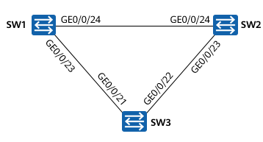

Case 1

* Deploy STP on the three switches to eliminate Layer 2 loops on the network.
* Configure SW1 as the root bridge and block GE0/0/22 on SW3.

SW1 configuration:

[SW1] **stp mode stp**

[SW1] **stp enable**

[SW1] **stp priority 0**

SW2 configuration:

[SW2] **stp mode stp**

[SW2] **stp enable**

[SW2] **stp priority 4096**

SW3 configuration:

[SW3] **stp mode stp**

[SW3] **stp enable**

Check brief information about STP states of ports on SW3.

<SW3> **display stp brief**

MSTID Port Role STP State Protection

0 GigabitEthernet0/0/21 ROOT FORWARDING NONE

0 GigabitEthernet0/0/22 ALTE DISCARDING NONE

## Improvements Made in RSTP

### Disadvantages of STP

STP ensures a loop-free network but is slow to converge, leading to service quality deterioration. If the network topology changes frequently, connections on the STP network are frequently torn down, causing frequent service interruption.

STP does not differentiate between port roles according to their states, making it difficult for less experienced administrators to learn about and deploy this protocol.

* Ports in Listening, Learning, and Blocking states are the same for users because none of these ports forwards service traffic.
* In terms of port use and configuration, the essential differences between ports lie in the port roles but not port states.
* Both root and designated ports can be in Listening state or Forwarding state, so the port roles cannot be differentiated according to their states.

The STP algorithm does not determine topology changes until the timer expires, delaying network convergence.

The STP algorithm requires the root bridge to send configuration BPDUs after the network topology becomes stable, and other devices process and spread the configuration BPDUs through the entire network. This also delays convergence.

### RSTP Overview

RSTP defined in IEEE 802.1w is an enhancement to STP. RSTP optimizes STP in many aspects, provides faster convergence, and is compatible with STP.

RSTP introduces new port roles. When the root port fails, the switch can enable the alternate port to obtain an alternate path from the designated bridge to the root bridge. RSTP defines three states for a port based on whether the port forwards user traffic and learns MAC addresses. In addition, RSTP introduces the edge port. The port connecting a switch to a terminal is configured as an edge port that enters the Forwarding state immediately after initialization, thus improving the working efficiency.

The IEEE 802.1w standard released in 2001 defines RSTP. RSTP is an improvement on STP and implements fast network topology convergence.

RSTP is evolved from STP and has the same working mechanism as STP. When the topology of a switching network changes, RSTP can use the Proposal/Agreement mechanism to quickly restore network connectivity.

RSTP removes three port states, defines two new port roles, and distinguishes port attributes based on port states and roles. In addition, RSTP provides enhanced features and protection measures to ensure network stability and fast convergence.

RSTP is backward compatible with STP, which is not recommended because STP slow convergence is exposed.

Improvements made in RSTP:

* RSTP processes configuration BPDUs differently from STP.
  + When the topology becomes stable, the mode of sending configuration BPDUs is optimized.
  + RSTP uses a shorter timeout interval of BPDUs.
  + RSTP optimizes the method of processing inferior BPDUs.
* RSTP changes the configuration BPDU format and uses the Flags field to describe port roles.
* RSTP topology change processing: Compared with STP, RSTP is optimized to accelerate the response to topology changes.

### Improvements Made in RSTP

RSTP processes configuration BPDUs differently from STP.

* When the topology becomes stable, the mode of sending configuration BPDUs is optimized.
* RSTP uses a shorter timeout interval of BPDUs.
* RSTP optimizes the method of processing inferior BPDUs.

RSTP changes the configuration BPDU format and uses the Flags field to describe port roles.

RSTP topology change processing: Compared with STP, RSTP is optimized to accelerate the response to topology changes.

### Port Roles in RSTP

RSTP adds port roles to help understand RSTP and simplify RSTP deployment.

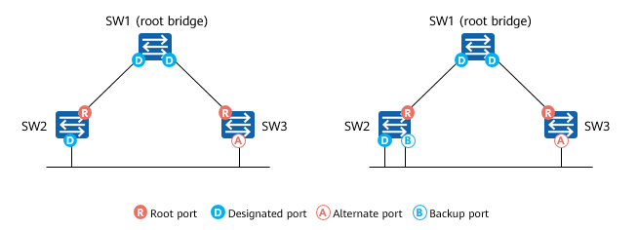

Port Roles in RSTP

RSTP defines four port roles: root port, designated port, alternate port, and backup port.

From the perspective of configuration BPDU transmission:

* An alternate port is blocked after learning a configuration BPDU sent from another network bridge.
* A backup port is blocked after learning a configuration BPDU sent from itself.

From the perspective of user traffic:

* An alternate port acts as a backup of the root port and provides an alternate path from the designated bridge to the root bridge.
* A backup port backs up a designated port and provides a backup path from the root bridge to the related network segment.

### Edge Port

An edge port is located at the edge of a region and does not connect to any switching device.

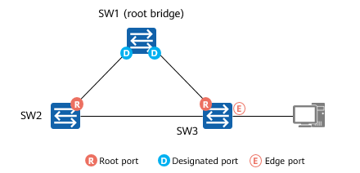

Edge Port

Generally, an edge port is directly connected to a user terminal. The edge port can transition from the Disabled state to the Forwarding state.

In STP, it takes 15 seconds for the port of a switch connected to a user terminal to transition from Disabled to Forwarding. During this period, the user terminal cannot access the Internet. If the network changes frequently, the Internet access status of the user terminal is unstable.

An edge port is directly connected to a user terminal and is not connected to any switching device. An edge port does not receive or process configuration BPDUs and does not participate in RSTP calculation. It can transition from Disabled to Forwarding without any delay. An edge port becomes a common STP port once it receives a configuration BPDU. The spanning tree needs to be recalculated, which leads to network flapping.

### Port States in RSTP

RSTP deletes two port states defined in STP, reducing the number of port states to three.

* If the port does not forward user traffic or learn MAC addresses, it is in Discarding state.
* If the port does not forward user traffic but learns MAC addresses, it is in Learning state.
* If the port forwards user traffic and learns MAC addresses, it is in Forwarding state.

Port States in RSTP

|  |  |  |
| --- | --- | --- |
| STP Port State | RSTP Port State | Port Role |
| Forwarding | Forwarding | Root port or designated port |
| Learning | Learning | Root port or designated port |
| Listening | Discarding | Root port or designated port |
| Blocking | Discarding | Alternate port or backup port |
| Disabled | Discarding | Disabled port |

## STP Advancement

### Defects of STP/RSTP: All VLANs Share One Spanning Tree

RSTP, an enhancement to STP, allows for fast network topology convergence.

STP and RSTP both have a defect: All VLANs on a LAN share one spanning tree. As a result, inter-VLAN load balancing cannot be performed, and blocked links cannot transmit any traffic, which may lead to VLAN packet transmission failures.

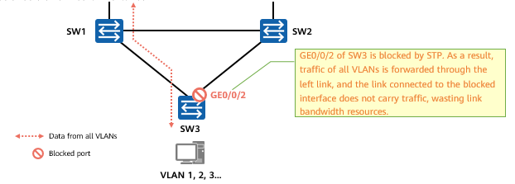

Defects of STP/RSTP

### VBST

Huawei provides the VLAN-based Spanning Tree (VBST). VBST constructs a spanning tree in each VLAN so that traffic from different VLANs is load balanced along different spanning trees.

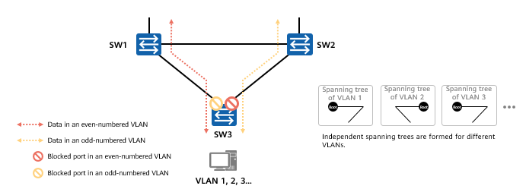

VBST

VBST brings in the following benefits:

* Eliminates loops.
* Implements link multiplexing and load balancing, and therefore improves link use efficiency.
* Reduces configuration and maintenance costs.

If a great number of VLANs exist on a network, spanning tree computation for each VPN consumes a huge number of switch processor resources.

### MSTP

To fix the defects, the IEEE released the 802.1s standard that defines the Multiple Spanning Tree Protocol (MSTP) in 2002.

MSTP is compatible with STP and RSTP, and can rapidly converge traffic and provides multiple paths to load balance VLAN traffic.

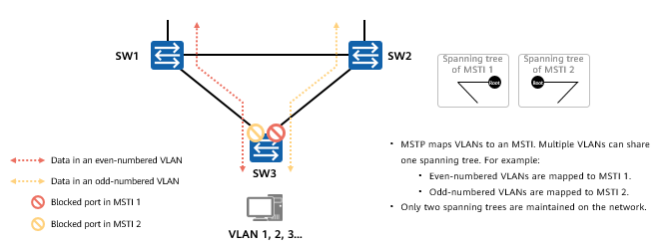

MSTP

MSTP Overview

* MSTP divides a switching network into multiple regions, each of which has multiple spanning trees that are independent of each other.
* Each spanning tree is called a multiple spanning tree instance (MSTI).
* An MSTI is the spanning tree corresponding to a set of VLANs.
* Binding multiple VLANs to a single MSTI reduces communication costs and resource usage.
* The topology of each MSTI is calculated independently, and traffic can be balanced among MSTIs.
* Multiple VLANs with the same topology can be mapped to a single MSTI. The forwarding state of the VLANs for an interface is determined by the interface state in the MSTI.

### Stack and Tree Networking of Campus Networks

Traditional STP Networking

* Two aggregation switches form a triangle Layer 2 loop with access switches, so STP must be deployed on the network. However, STP blocks ports on the network, causing a failure to fully utilize link bandwidth.

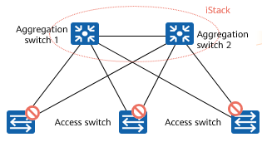

Traditional STP Networking

iStack Networking

* Aggregation switches are stacked to form a single logical device, simplifying the network topology. In addition, link aggregation is deployed between aggregation switches and access switches to simplify the network topology to a tree topology, eliminating Layer 2 loops and improving link bandwidth utilization.

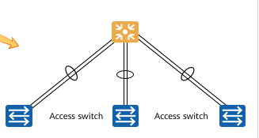

iStack Networking

Intelligent Stack (iStack) enables multiple iStack-capable switches to function as a logical device.

Before an iStack system is set up, each switch is an independent entity and has its own IP address and MAC address. You need to manage the switches separately. After an iStack system is set up, switches in the iStack system form a logical entity and can be managed and maintained using a single IP address. iStack technology improves forwarding performance and network reliability, and simplifies network management.

### Smart Link

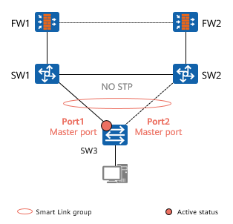

Smart Link

Smart Link is tailored for dual-uplink networking.

* Smart Link is deployed on two switches where a host is dual-homed. When the network is normal, one of the two uplinks is active, and the other is in standby state (does not carry service traffic). In this way, a Layer 2 loop is eliminated.
* When the active link is faulty, traffic is switched to the standby link in milliseconds. This ensures proper data forwarding.
* Smart Link is easy to configure.
* Smart Link does not involve protocol packet exchange, therefore greatly improving speed and reliability.

As shown in the figure, SW3 is connected to FW1 and FW2 through dual uplinks. In this way, Switch3 has two uplinks to the uplink device. Smart Link can be configured on SW3. In normal situations, the link on Port2 functions as a backup link. If the link on Port1 fails, Smart Link automatically switches data traffic to the link on Port2 to ensure service continuity.

## Quiz

1. (Single)Which statement about the STP port state is false? ( )
2. The blocked port does not listen to or send BPDUs.
3. A port in learning state learns MAC addresses but does not forward data.
4. A port in Listening state keeps listening to BPDUs.
5. If a blocked port does not receive BPDUs within a specified period, the port automatically switches to the Listening state.
6. (Single)What port states does a standard spanning tree have? ( )
7. 3
8. 4
9. 5
10. 6
11. (Single)Which of the following statements about STP are correct? ( )
12. The root bridge does not have a designated port.
13. The root bridge does not have a root port.
14. A non-root bridge may have one root port and multiple designated ports.
15. A non-root bridge may have multiple root ports and a designated port.
16. (Multiple)Which of the following statements about STP are correct? ( )
17. Two different switches cannot have the same priority.
18. The smaller the bridge ID of a switch, the more likely it is to become the root bridge.
19. The PID value does not affect the election result of the root bridge.
20. The priority of the bridge ID ranges from 0 to 65535.
21. (True or False)In STP, the default Hello Time of BPDUs is set to 1s. ( )
22. True
23. False
24. (True or False)The blocked port on the STP can learn the MAC address of user traffic but cannot forward user traffic. ( )
25. True
26. False

## Summary

STP prevents loops on a LAN. Devices running STP exchange information with one another to discover loops on the network, and block certain ports to eliminate loops. With the growth in scale of LANs, STP has become an important protocol for a LAN.

After STP is configured on an Ethernet switching network, the protocol calculates the network topology to implement the following functions:

* Loop prevention: The spanning tree protocol blocks redundant links to prevent potential loops on the network.
* Link redundancy: If an active link fails and a redundant link exists, the spanning tree protocol activates the redundant link to ensure network connectivity.

STP cannot meet requirements of modern campus networks. However, understanding the working mechanism of STP helps you better understand the working mechanism and deployment of RSTP and MSTP.